Date: 15th June RECEPTION PLANNING
Activity | Phonics (to be done in this order) | Literacy
We're going on a dino-hunt! Can you find the clues that dinosaurs have been stomping around in your space? It could be a broken branch, a huge puddle that could be a dinosaur footprint, some scratch marks on the wall or leaves that have been munched by a hungry herbivore!  Now make something that will catch it! You could weave a net, make a dino-jail from sticks and logs, create a sticky mud pit - and don't forget about the bait a nice big juicy pile of leaves!  https://www.nhm.ac.uk/discover/jurassic-scavenger-hunt.html  Make dino cookies https://www.nhm.ac.uk/discover/dinosaur-footprint-cookies-recipe.html  Prehistoric paint – in pre-historic times there was no paint but people used to make their own. Can you make your own? Go on a natural colour hunt and look for as many different colours or shades – mud, leaves, petals, moss, fruit etc. Squish and grind what you find and mix with a small amount of water to make a coloured paste. Now create a muddy masterpiece with a stick – can you paint a dinosaur? | This week’s digraph is er (better letter)  Watch Mr Thorne Does Phonics er  https://www.youtube.com/watch?v=WaxZN4BZjgc  Watch BBC bitesize er  https://www.bbc.co.uk/bitesize/topics/zvq9bdm/articles/zvmnmfr  Play Picnic on Pluto er Phonics Play  Username: march20 Password: home  - Try writing g-er-m, f-er-n, o-tt-er, r-i-v-er  - m-o-n-s-t-er  - Can you think of more words containing er sounds? Try writing some! | What would you and your family be called if you were dinosaurs?  E.g Jack-o-saurus ,  Max-i-rapter  Take pictures of you and your dinosaurs (or other toys) around and about e.g. outside, in the kitchen, bathroom etc. Can you write a caption about it?  What kind of food would Drip like? Talk about what Drip wanted to eat in the story and other foods he might like and make a menu especially for him.
Please remember to read favourite stories with your child.  Here are more dinosaur stories;  Captain Flinn and the Pirate Dinosaurs  https://www.youtube.com/watch?v=3a7PJLqPfBA  If I had a Dinosaur  https://www.youtube.com/watch?v=og9xn8WoyDs  Dinosaur Bones by Bob Banner  https://www.youtube.com/watch?v=XPvthRr31os  Visit the dinosaur section of the Natural History Museum online.  https://www.nhm.ac.uk/discover/dinosaurs.htm | 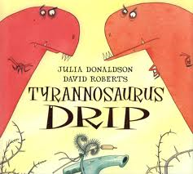  Tyrannasaurus Drip  https://www.youtube.com/watch?v=tfvv9GLmaUM | Daily key words:  Can you look at all the key words you have learnt to date? See how many you still know.  Years ago people didn’t have pencils – could you use chalk, charcoal or crayons to write some keywords?
Maths (number) | Maths (shape, space & measure) | Physical
Oviraptor (egg thief) – addition, subtraction and number bonds  First look for natural items like twigs and leaves, or if you are inside you could use towels and cushions to make a dino nest! Then make 10 paper eggs, or use 10 bricks or balls and put them in your nest.  Start with your grown up being the oviraptor and you the nesting dinosaur, close your eyes so the oviraptor can steal some eggs from your nest. Open your eyes and try to work out how many eggs have been stolen? You could use a numberline to help you work it out or use your tens frame. You can take turns being the oviraptor!  Extension – can you have 15, 20, or more eggs in your nest to play the game? | Click on the picture to watch the Herbivore/Carnivore ppt  Then sort the dinosaurs into the correct groups – see below | DinoDisco! Get on your dancing shoes and dance the dinosaur way. Go foraging for some prehistoric instruments from nature - stick and logs for drums and grass whistles. Play your instruments quickly and slowly, loud and quiet etc  Now move like a dinosaur – stamp, swish your tail to the beat like a diplodocus, shake your head like a T-Rex, shake your spines like a stegosaurus, wave your short arms like a velociraptor  Make a dinosaur den!
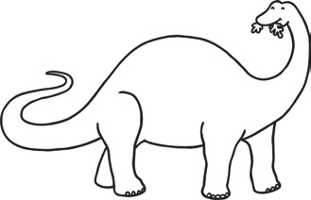  Apatosaurus  twinkl.com | 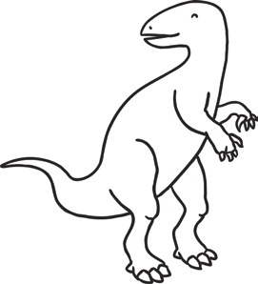  Iguanodon  twinkl.com | 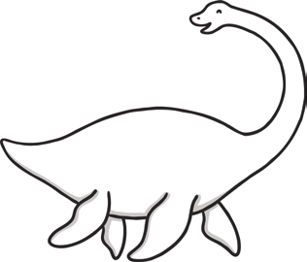  Plesiosaur  twinkl.com | 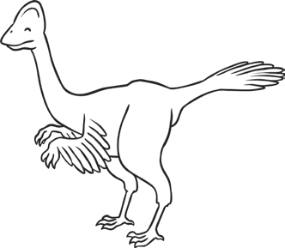  Oviraptor  twinkl.com
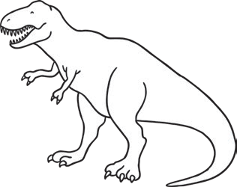  Tyrannosaurus Rex  twinkl.com | 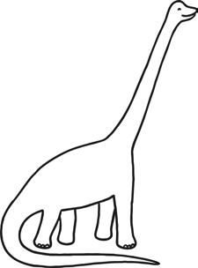  Brachiosaurus  twinkl.com | 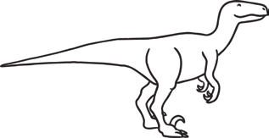  Velociraptor  twinkl.com | 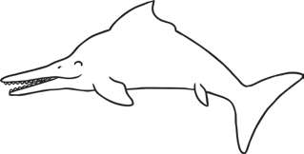  Ichthyosautrwinkl.com
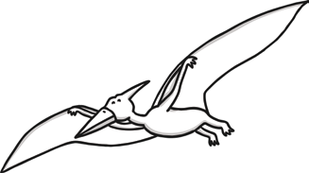  Pterodactyl  twinkl.com | 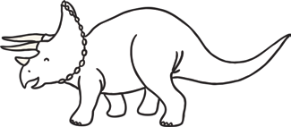  Triceratops  twinkl.com | 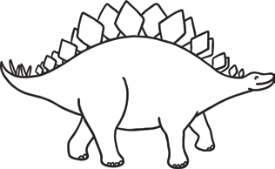  Stegosaurus  twinkl.com

Sort the creatures into the correct section of the Venn diagram below.

Carnivore Herbivore

Velociraptor

Omnivore

Apatosaurus

Plesiosaur

Tyrannosaurus Rex

Ichthyosaur

Oviraptor

Iguanodon

Triceratops
Brachiosaurus

Pterodactyl
Stegosaurus

