Date: 22nd June 2020 RECEPTION PLANNING
Activity | Phonics (to be done in this order) | Literacy
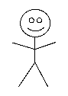  Design your own family tree and  draw your stickman family.  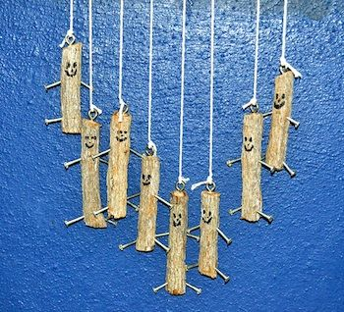  You could then make a  stick mobile to hang that  has your family on, or you  and your friends | Revise the sounds, ee and oa.  - Buried treasure game will allow you to click on these sounds to practice reading them in words.  - phonics play (see link below) phase 3 for ee and oa  - https://www.phonicsplay.co.uk/resources/phase/2/buried-treasure  - can you write some of these b- oa-t g-oa-t t-r-ee d-ee-p  phonics play https://www.phonicsplay.co.uk/  username; march20 password; home | Write the words in the story that have the two phonic sounds in, ee and oa  Some words rhyme in this story. Find the words that rhyme and write them on card/paper as rhyming pairs. You could use these to play a matching game.  Look at the ’parts of a tree’ poster and follow the instructions.
Suggested books to read with your child  Please don’t forget to read favourite stories with your child.  Other stories by Julia Donaldson that rhyme,  Zog,  https://www.dailymotion.com/video/x65bulb  The Smartest Giant in Town  https://www.youtube.com/watch?v=cfiPrA8E3qE | Stick Man  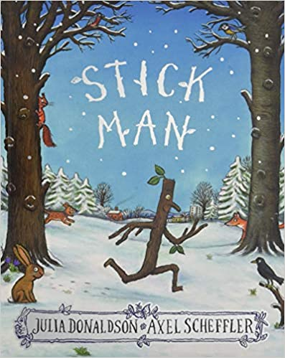  https://www.youtube.com/watch?v=P8pKjYgjPLI | Keywords  Revise key words for reading and writing,  as, at, a, an, it, is, I, am, man, dad, dog, did, and, not, got, can, cat, to, do.
Maths Number | Shape space and measure | Physical
Using sticks or pencils/ straws etc put them in groups of two and count them in two’s up to 20.  Form the numbers 1,4,7,11,14,17,44,47,74,77 with your straight sticks.  Start with using the Stick Man addition sheet – see below  Then using your own sticks and the signs  + and = create your own number sentences. | Using your sticks/pencils/straws create your own 2d shapes, square, rectangle, triangle, hexagon and pentagon.  Twig size ordering – see below.  Find some sticks and put them in height order too.  Prepositions (under/on/in/between) – see sheet below.  Gather some toys and ask the same questions ie put the teddy on the table, put the car in the castle. | 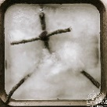  Make a stick man and see if he floats.  Make him out of safe junk modelling/natural things from the garden. Wrap him in wool/cotton/string for clothes.

Stick Man
Stick man lives in the family tree  With his Stick Lady Love and their stick children three.  One day he wakes early and goes for a jog.  Stick Man, oh Stick Man, beware of the dog!  “A stick barks the dog. An excellent stick!  The right kind of stick for my favourite trick  I’ll fetch it and drop it and fetch it – and then  I’ll drop it and fetch it and drop it again.”  “I’m not a stick! Why can’t you see,  I’m Stick Man, I’m Stick Man, I’m Stick Man, that’s me,  And I want to go home to the family tree!”  A notice says dogs must be kept on the lead.  At last the game’s over, and Stick Man is freed. | 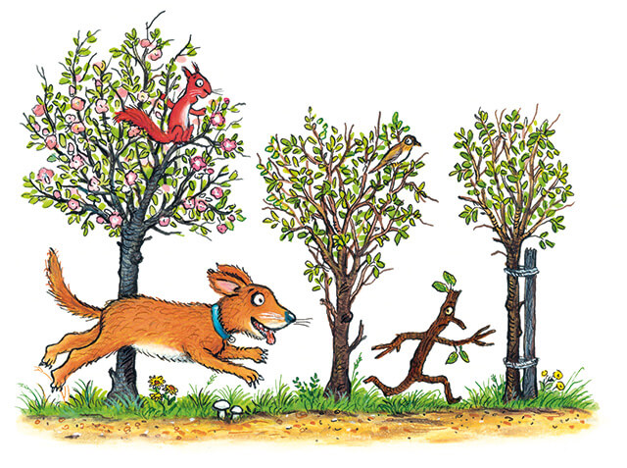

He sets off for home with a hop and a twirl  Stick Man, Stick Man, beware of the girl!  “A stick! cries the girl with a smile on her face  The right kind of Pooh-stick for winning the race!  Has everyone got one? Get ready to throw!  It’s 1,2,3 – into the river they go!”  “I’m not a Pooh-stick! Why can’t they see,  I’m Stick Man, I’m Stick Man, I’m Stick Man, that’s me,  And I’m heading away from the family tree!”  Stick Man is floating. He floats on and on  Stick man, oh Stick man, beware of the swan!  “A twig! Says the swan. This twig is the best!  It’s the right kind of twig to weave into my nest.”  “I’m not a twig! Why can’t they see,  I’m Stick Man, I’m Stick Man, I’m Stick Man, that’s me,  And I long to be back in the family tree.” | The nest is deserted, and Stick Man is free.  He drifts down the river and sails out to sea!  He tosses and turns, till the frolicking foam  Washes him up on a beach far from home.  Here comes a dad with a spade in his hand.  Stick Man, oh I’m Stick Man, beware of the sand!  “A mast!” Yells the dad. “An excellent mast!  Hooray! There’s a flag on our castle at last.”  “I’m not a mast for a silly old flag, or a sword for a knight, or a hook for a bag. I’m not a pen! I’m not a bowl, I’m not a bat… or a boomerang – no, I’m……..”  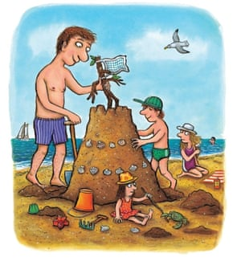

Stick Man, oh Stick Man, beware of the snow!  Here comes a boy in a warm woolly scarf.  “An arm for my snowman! He says with a laugh.”  “I’m not an arm! Can nobody see  I’m Stick Man, I’m Stick Man, I’m Stick Man, that’s me.  Will I ever get back to the family tree?”  Stick Man is lonely; Stick Man is lost.  Stick Man is frozen and covered in frost.  Stick man is weary. His eyes start to close.  He stretches and yawns and lies down for a doze.  He can’t hear the bells, or the sweet-singing choir…  Or the voice saying, “Here’s a good stick for the fire!”  Stick Man is lying asleep in the grate.  Can anyone wake him before it’s too late?  He dreams of his kids and his Stick Lady Love,  Then suddenly wakes. What’s that noise up above!  It starts as a chuckle then turns to a shout:  “Oh-oh-oh-oh-oh… I’m stuck, get me out!” | A stuck Man! A Stuck man! Now who could that be?  “Don’t worry!” cries Stick Man. “I’ll soon set you free!”  A scratch and a scrape and a flurry of soot.  A wiggle, a jiggle, and – out pokes a foot!  A shove and a nudge, a hop and a jump…  And Santa falls into the room with a thump!  “Stick Man, oh Stick Man, you excellent friend!  Thanks! Thanks a million! Thanks without end!”  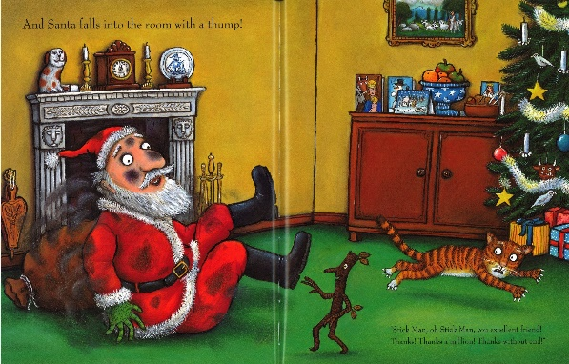

Then Stick Man helps Santa deliver the toys  To fast asleep girls and to fast asleep boys.  Faster and faster they fly through the snow,  Till Santa says, “Only one chimney to go!”  Stick Lady’s lonely. The children are sad.  It won’t feel like Christmas without their Stick Dad.  They toss and they turn in the family bed.  But what is that clattering sound overhead?  Someone is tumbling into their house.  Is it a bird, or a bat, or a mouse?  Or could it…yes, could it just possibly be….  “I’m Stick Man, I’m Stick Man, I’m Stick Man, that’s me!  And I’m sticking right here in the family tree.” | 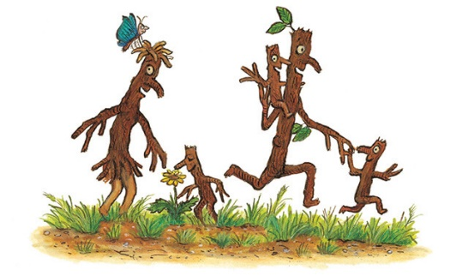

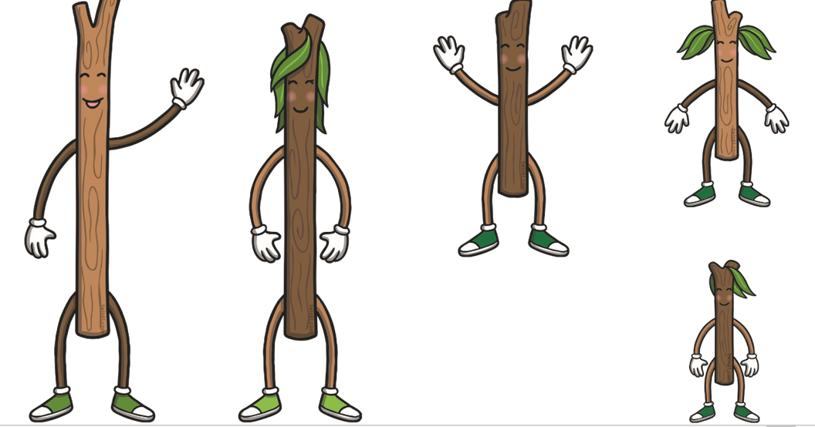

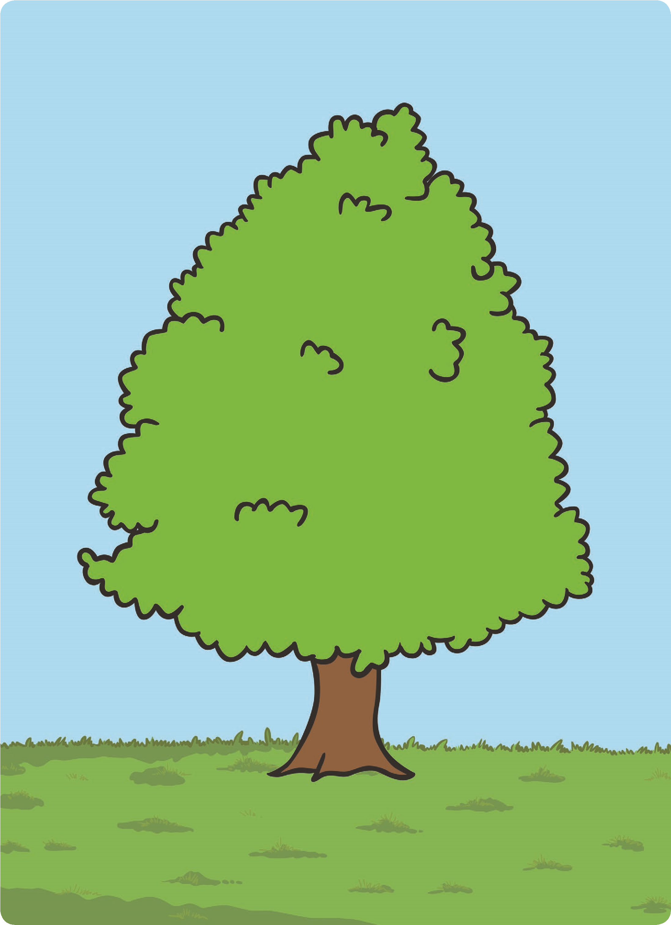
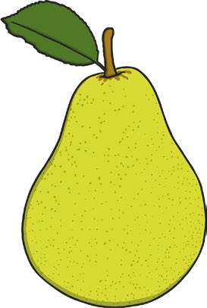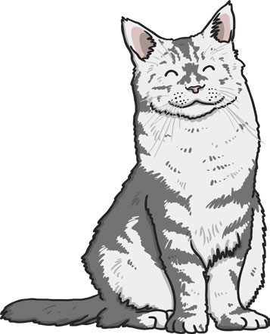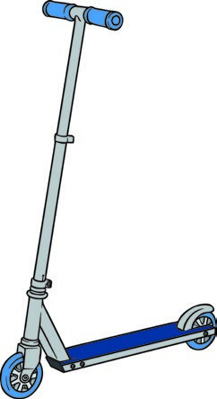
twinkl.co.uk
twinkl.co.uk
twinkl.co.uk
twinkl.co.uk
twinkl.co.uk
twinkl.co.uk
Put the scooter
under
the tree.
Put the bird
between
the pear
and the tree.
Put the cat

in
the tree.
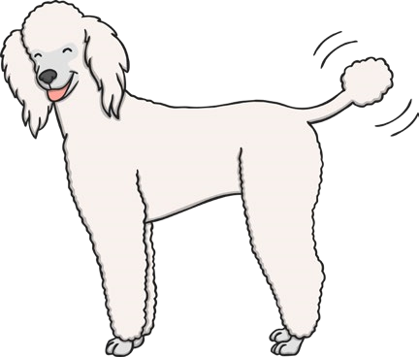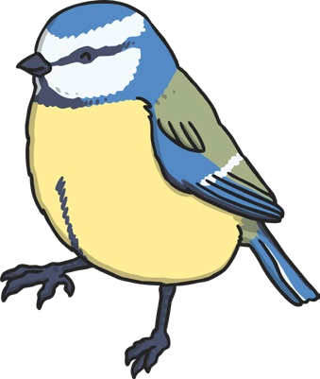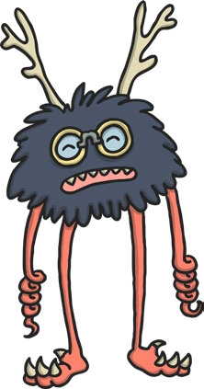
twinkl.co.uk
twinkl.co.uk
twinkl.co.uk
twinkl.co.uk
twinkl.co.uk
twinkl.co.uk
Put the ball

on
the scooter.
Put the pear

beside
the tree.
Put the dog

below
the tree.
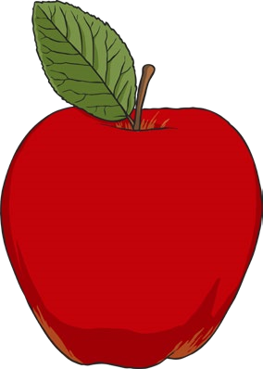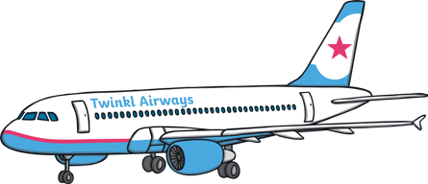
twinkl.co.uk
twinkl.co.uk
twinkl.co.uk
twinkl.co.uk
twinkl.co.uk
twinkl.co.uk
Put the apple

in front
of the tree.
Put the aeroplane
above
the tree.
Put the monster
over
the tree.

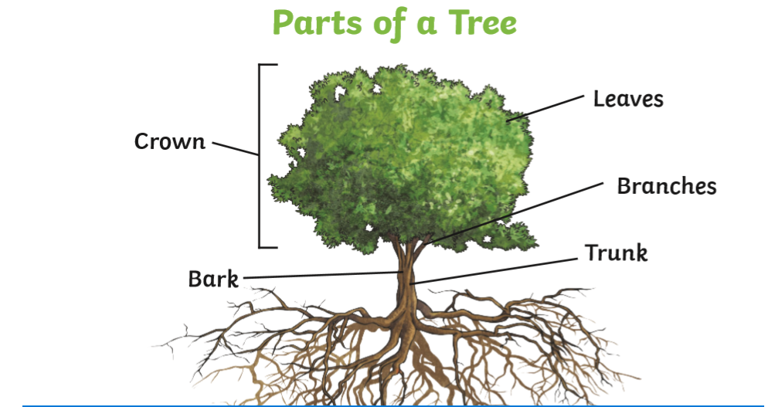
Can you find and talk about these parts of a tree? Maybe draw your own tree and label.
Design and create your own fabulous Stick Man tree.
Talk about what grows on trees that you can eat.
Paint or draw a forest that has lots of trees.

